Variation 2 Answer Key
Campus Comps: Building a Data Website with an AI Coding Agent
[Author name]
This key gives the answer to each of the six Variation 2 questions, as computed by the reference code. For each question it shows the figures, a chart, a model answer, the common wrong answers with the figures they produce, and the tolerance for marking. The workbook Variation 2 Answer Key.xlsx holds the same figures.
The case's definitions apply throughout: a valid sale is $1,000 or more; price per square foot is computed per valid sale with at least 100 sq ft, then the median is taken; days on market runs from list_date to contract_date; groups under 20 sales show "fewer than 20 sales"; medians, not means.
Mark an answer correct when it is within the tolerance stated for its question. The tolerances allow for rounding but not for a different definition: each common wrong answer below falls outside them.
To regenerate every number here, run python run_all.py in instructor/reference-code.

Question 1. Price levels
For each campus area, what are the median sale price and the median price per square foot? Which areas are highest and lowest on each measure? Does the ranking change between the two measures, and why might it?

Figures
Price levels by campus area
Campus area | Valid sales | Median sale price | Rank | Sales with price per sq ft | Median price per sq ft | Rank
University of California, Davis | 941 | $889,000 | 1 | 941 | $492.71 | 1
The University of North Carolina at Chapel Hill | 3,016 | $725,000 | 2 | 3,005 | $280.25 | 2
University of Virginia | 2,774 | $615,000 | 3 | 2,772 | $270.03 | 3
University of Michigan | 3,020 | $571,000 | 4 | 3,010 | $259.11 | 4
University of Wisconsin-Madison | 5,706 | $434,010 | 5 | 5,705 | $249.16 | 5
The Pennsylvania State University | 1,350 | $430,000 | 6 | 1,345 | $207.42 | 6
University of Georgia | 2,813 | $370,000 | 7 | 2,361 | $196.82 | 8
University of Florida | 5,629 | $355,000 | 8 | 5,623 | $203.24 | 7
The University of Iowa | 1,909 | $342,000 | 9 | 1,907 | $175.91 | 9
Purdue University | 4,616 | $299,900 | 10 | 4,615 | $168.24 | 10
University of Illinois Urbana-Champaign | 3,664 | $245,000 | 11 | 3,650 | $150.30 | 11

Chart
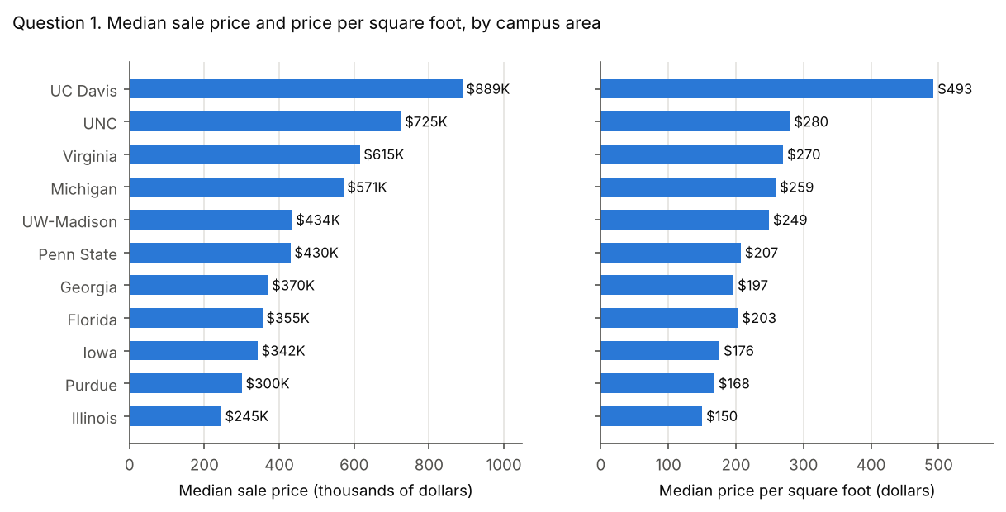

Model answer
UC Davis is highest on both measures, with a median sale price of $889,000 and $492.71 per square foot. Illinois is lowest on both, at $245,000 and $150.30.
The ranking barely changes. Only Georgia and Florida trade places, at 7 and 8. Georgia homes sell for more ($370,000 against $355,000), but they are larger (median 1,902 sq ft against 1,756), so they cost less per square foot. Price per square foot adjusts for size; median price does not.

Common wrong answers
Mean instead of median. Means are pulled up by a few very expensive sales, up to $81,510,000.
Campus area | correct: median of valid sales | mean instead of median
Purdue University | $299,900 | $328,005
The Pennsylvania State University | $430,000 | $473,855
The University of Iowa | $342,000 | $389,734
The University of North Carolina at Chapel Hill | $725,000 | $825,205
University of California, Davis | $889,000 | $976,896
University of Florida | $355,000 | $405,889
University of Georgia | $370,000 | $491,552
University of Illinois Urbana-Champaign | $245,000 | $277,416
University of Michigan | $571,000 | $657,210
University of Virginia | $615,000 | $795,448
University of Wisconsin-Madison | $434,010 | $503,387

Ratio of medians, mean of ratios, or blank areas divided. Price per square foot is a median of per-sale values. Dividing the median price by the median area, averaging, or letting a blank or 0 sq ft area divide (JavaScript returns Infinity) each gives a different figure.
Campus area | correct: median of per-sale values | median price / median living area | mean of per-sale values | no area floor, blank or 0 sq ft divided as 0
Purdue University | $168.24 | $164.42 | $166.68 | $168.25
The Pennsylvania State University | $207.42 | $202.45 | $217.25 | $208.15
The University of Iowa | $175.91 | $168.14 | $182.41 | $175.93
The University of North Carolina at Chapel Hill | $280.25 | $277.57 | $299.72 | $280.43
University of California, Davis | $492.71 | $482.63 | $500.44 | $492.71
University of Florida | $203.24 | $202.16 | $210.28 | $203.32
University of Georgia | $196.82 | $198.76 | $220.94 | $209.30
University of Illinois Urbana-Champaign | $150.30 | $147.59 | $151.44 | $150.55
University of Michigan | $259.11 | $257.09 | $281.41 | $259.28
University of Virginia | $270.03 | $257.54 | $298.89 | $270.06
University of Wisconsin-Madison | $249.16 | $243.28 | $267.46 | $249.16

Tolerance
- Median sale price: within $1,000 of the key. Rounding to the nearest thousand is fine.
- Median price per sq ft: within $1.00.
- Ranking: the site must name UC Davis highest and Illinois lowest on both measures, and notice that Georgia and Florida swap. Any reason based on home size earns full credit.

Question 2. Speed
For each campus area, what is the median days on market? What share of sales has no days on market because a date is missing? Which areas sell fastest, and how could the missing share affect the comparison?

Figures
Days on market by campus area
Campus area | Sales | Sales with days on market | Median days on market | Share with no days on market
University of Wisconsin-Madison | 5,706 | 4,628 | 7 | 18.9%
University of Michigan | 3,021 | 2,450 | 7 | 18.9%
University of Illinois Urbana-Champaign | 3,664 | 2,868 | 7 | 21.7%
University of Virginia | 2,775 | 2,056 | 7 | 25.9%
The Pennsylvania State University | 1,351 | 908 | 8 | 32.8%
Purdue University | 4,616 | 3,897 | 10 | 15.6%
The University of North Carolina at Chapel Hill | 3,016 | 2,411 | 10 | 20.1%
University of California, Davis | 941 | 792 | 11 | 15.8%
The University of Iowa | 1,909 | 1,248 | 23.5 | 34.6%
University of Florida | 5,629 | 4,505 | 25 | 20.0%
University of Georgia | 2,814 | 2,279 | 27 | 19.0%

Chart
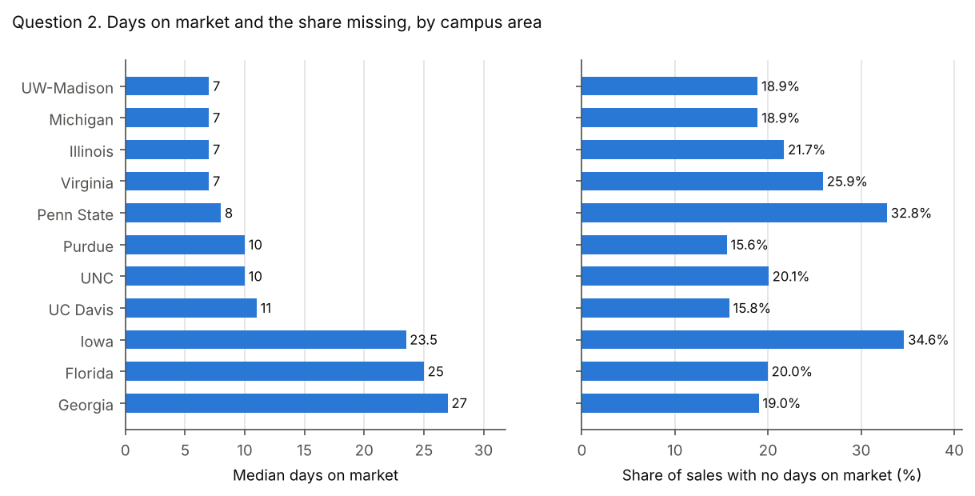

Model answer
Four areas tie as the fastest, at a median of 7 days: Illinois, Michigan, UW-Madison and Virginia. The slowest are Georgia (27), Florida (25) and Iowa (23.5).
Between 15.6% (Purdue) and 34.6% (Iowa) of sales have no days on market. Those sales are mostly off-market and new construction sales, so they are not a random sample. The medians describe only homes that were listed, and areas with a large missing share, such as Iowa and Penn State, are the least comparable.

Common wrong answers
Measured to sale_date, blanks as zero, or a mean. Days on market ends at contract_date. Using sale_date adds the time to close. Treating a blank date as 0 makes unlisted homes look instant. A mean is pulled up by homes that took over a year.
Campus area | correct: list_date to contract_date | measured to sale_date | blanks treated as zero | mean instead of median
Purdue University | 10 | 45 | 5 | 27.8
The Pennsylvania State University | 8 | 53 | 4 | 29.3
The University of Iowa | 23.5 | 62 | 3 | 41.6
The University of North Carolina at Chapel Hill | 10 | 50 | 6 | 34.5
University of California, Davis | 11 | 38 | 8 | 29.5
University of Florida | 25 | 67 | 13 | 52.8
University of Georgia | 27 | 56 | 16 | 52.1
University of Illinois Urbana-Champaign | 7 | 52 | 5 | 27.7
University of Michigan | 7 | 39 | 5 | 25.4
University of Virginia | 7 | 57 | 5 | 29.4
University of Wisconsin-Madison | 7 | 44 | 6 | 21.6

Missing share counts only list_date. A sale needs both dates. Counting only a missing list_date misses sales with a list date but no contract date.
Campus area | correct: missing either date | counting only a missing list_date
Purdue University | 15.6% | 6.2%
The Pennsylvania State University | 32.8% | 31.8%
The University of Iowa | 34.6% | 9.4%
The University of North Carolina at Chapel Hill | 20.1% | 19.5%
University of California, Davis | 15.8% | 15.3%
University of Florida | 20.0% | 18.6%
University of Georgia | 19.0% | 16.1%
University of Illinois Urbana-Champaign | 21.7% | 20.9%
University of Michigan | 18.9% | 17.1%
University of Virginia | 25.9% | 25.4%
University of Wisconsin-Madison | 18.9% | 18.6%

Tolerance
- Median days on market: within 0.5 days. For Iowa, 23.5 and 24 are both correct.
- Share with no days on market: within 0.5 percentage points.
- The comment on the missing share should say the missing sales are not random, or that the comparison covers listed homes only.

Question 3. Distance
For each campus area, what is the median price per square foot in each distance band? In most areas, does price per square foot fall as the distance from campus grows? Say what you count as falling, and name any area where it does not.

Figures
Median price per sq ft by distance band
Campus area | Under 1 mile | 1 to under 2 miles | 2 to under 5 miles | 5 to under 10 miles | 10 miles or more
University of Wisconsin-Madison | $361.21 | $365.72 | $268.44 | $231.40 | fewer than 20 sales
University of Florida | $243.72 | $212.90 | $191.27 | $213.05 | $193.37
Purdue University | $192.34 | $156.25 | $167.76 | $169.70 | $167.77
University of Illinois Urbana-Champaign | $159.98 | $136.70 | $150.59 | $198.20 | no sales
University of Michigan | $427.52 | $332.21 | $237.26 | $212.99 | fewer than 20 sales
The University of North Carolina at Chapel Hill | $400.18 | $311.09 | $284.53 | $265.15 | $224.32
University of Virginia | $340.50 | $317.04 | $266.83 | $253.95 | $220.23
University of Georgia | $271.19 | $280.68 | $192.18 | $185.52 | no sales
The University of Iowa | $205.59 | $175.98 | $171.94 | $177.70 | no sales
The Pennsylvania State University | $268.06 | $204.25 | $200.60 | no sales | no sales
University of California, Davis | $524.89 | $497.78 | $485.69 | fewer than 20 sales | no sales

Sales in each cell
Campus area | Under 1 mile | 1 to under 2 miles | 2 to under 5 miles | 5 to under 10 miles | 10 miles or more
University of Wisconsin-Madison | 85 | 286 | 2,588 | 2,744 | 2
University of Florida | 136 | 471 | 2,711 | 2,272 | 33
Purdue University | 102 | 339 | 2,715 | 1,393 | 66
University of Illinois Urbana-Champaign | 132 | 751 | 2,554 | 213 | 0
University of Michigan | 179 | 790 | 1,624 | 414 | 3
The University of North Carolina at Chapel Hill | 127 | 420 | 1,412 | 959 | 87
University of Virginia | 153 | 466 | 1,234 | 865 | 54
University of Georgia | 84 | 354 | 1,349 | 574 | 0
The University of Iowa | 171 | 635 | 1,072 | 29 | 0
The Pennsylvania State University | 218 | 363 | 764 | 0 | 0
University of California, Davis | 76 | 358 | 499 | 8 | 0

Pattern by area
Campus area | Pattern | Highest band | Largest rise between neighboring bands
University of Wisconsin-Madison | falls overall | 1 to under 2 miles | 1.2%
University of Florida | does not fall | Under 1 mile | 11.4%
Purdue University | does not fall | Under 1 mile | 7.4%
University of Illinois Urbana-Champaign | does not fall | 5 to under 10 miles | 31.6%
University of Michigan | falls at every step | Under 1 mile | 0.0%
The University of North Carolina at Chapel Hill | falls at every step | Under 1 mile | 0.0%
University of Virginia | falls at every step | Under 1 mile | 0.0%
University of Georgia | falls overall | 1 to under 2 miles | 3.5%
The University of Iowa | falls overall | Under 1 mile | 3.3%
The Pennsylvania State University | falls at every step | Under 1 mile | 0.0%
University of California, Davis | falls at every step | Under 1 mile | 0.0%

A rise of 0.0% means price per square foot never rises from one band to the next.
Areas that fall under three common rules
Rule for "falls" | Areas that fall | Areas that do not fall
Each band with enough sales is lower than the one before | 5 | Florida, Georgia, Illinois, Iowa, Purdue and UW-Madison
The farthest band with enough sales is lower than the nearest, and no step rises by more than 5% (the key's rule) | 8 | Florida, Illinois and Purdue
The farthest band with enough sales is lower than the nearest | 10 | Illinois

Students must say what they count as falling. Mark the answer against the student's own rule.

Chart
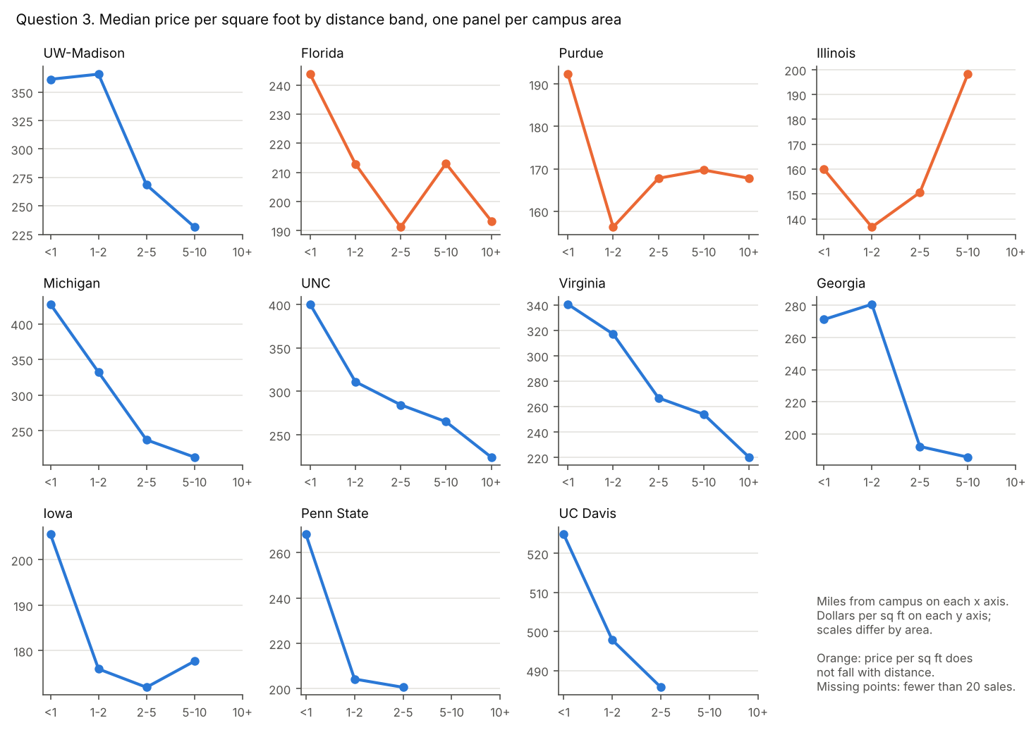

Model answer
Yes, in most areas. Price per square foot is highest within 1 mile of campus in 8 of 11 areas, and it falls with distance in 8: at every step in Michigan, Penn State, UC Davis, UNC and Virginia, and overall, with no rise between neighboring bands above 5.0%, in Georgia, Iowa and UW-Madison.
It does not fall in Florida, Illinois and Purdue. Illinois is the clearest exception: its highest band is 5 to under 10 miles ($198.20, against $159.98 under 1 mile).
Nine of the 55 cells have fewer than 20 sales, all in the outer bands, and show "fewer than 20 sales" or no sales.

Common wrong answers
All areas pooled into one line. Pooling mixes areas with different price levels. The outer bands are dominated by a few areas, so the pooled line rises again even though most areas fall.
Band | Sales | Median price per sq ft
Under 1 mile | 1,463 | $281.26
1 to under 2 miles | 5,233 | $238.43
2 to under 5 miles | 18,522 | $201.44
5 to under 10 miles | 9,471 | $217.34
10 miles or more | 245 | $207.28

Small cells shown. These medians rest on fewer than 20 sales and must be replaced by "fewer than 20 sales".
Campus area | Band | Sales | Median shown in error
University of California, Davis | 5 to under 10 miles | 8 | $610.78
University of Michigan | 10 miles or more | 3 | $143.38
University of Wisconsin-Madison | 10 miles or more | 2 | $206.18

Tolerance
- Each reportable cell: within $1.00.
- Every cell with 1 to 19 sales shows "fewer than 20 sales". A cell with no sales may show that, a dash or "no sales".
- The answer states a rule for "falls" and applies it correctly; the table above gives the result under three common rules. Under each of them most areas fall, except under the strictest rule, where 5 of 11 fall.
- Every rule names Illinois. Naming an area that falls at every step (Michigan, Penn State, UC Davis, UNC and Virginia) is wrong under any rule.

Question 4. Timing
Across all areas, pooled together, what is the median days on market for each calendar month in which homes were listed? Use only homes listed from April 1, 2023 through March 31, 2025, so that each calendar month covers exactly two years. Group them by the month of list_date. Which months are fastest, and which are slowest?

Figures
Days on market by month listed, homes listed April 1, 2023 to March 31, 2025
Month listed | Listings with days on market | Median days on market
January | 1,196 | 14.5
February | 1,511 | 9
March | 1,990 | 8
April | 2,041 | 6
May | 2,131 | 6
June | 1,992 | 8
July | 1,584 | 10
August | 1,489 | 16
September | 1,493 | 14
October | 1,442 | 16
November | 1,035 | 19
December | 653 | 21

Chart
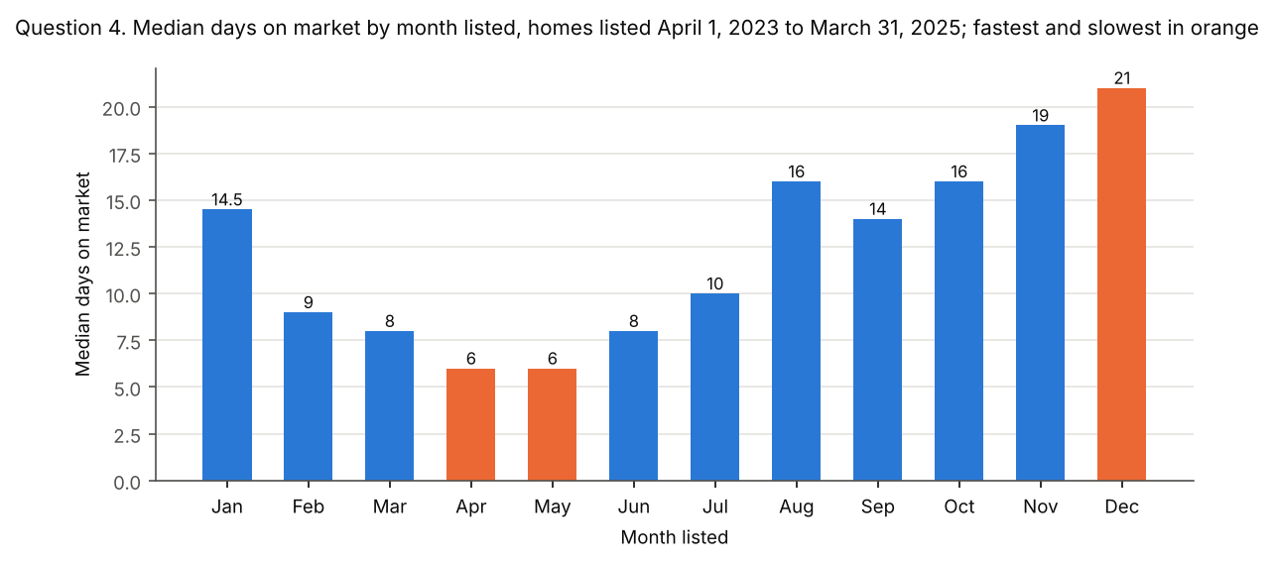

Model answer
Homes listed in April and May go under contract fastest, at a median of 6 days. December listings are slowest (21 days), followed by November (19).
Spring listings sell fastest and late-year listings slowest, the usual pattern of a spring buying season.

Common wrong answers
No window, wrong month or wrong end date. Listings outside the window are incomplete. Grouping by the month of sale_date describes when homes closed, not when they were listed. Measuring to sale_date adds the time to close. Treating blank dates as 0 pulls every month down.
Month | correct: listed April 2023 to March 2025 | all years combined (no window) | month of sale_date instead of list_date | measured to sale_date | blanks treated as zero
January | 14.5 | 12 | 31 | 51 | 12.5
February | 9 | 8 | 15.5 | 48 | 8
March | 8 | 7 | 9.5 | 50 | 7
April | 6 | 7 | 7 | 46 | 6
May | 6 | 7 | 7 | 44 | 6
June | 8 | 10 | 6 | 46 | 8
July | 10 | 13 | 7 | 46 | 8
August | 16 | 18 | 8 | 55 | 14
September | 14 | 17 | 12 | 53 | 14
October | 16 | 17 | 14 | 52 | 14
November | 19 | 20 | 14 | 57 | 18
December | 21 | 25 | 20 | 62 | 20

Tolerance
- Each month: within 0.5 days.
- Fastest: April and May. Slowest: December. Naming November as the second slowest is good but not required.

Question 5. Assessment
For each campus area, what is the median ratio of tax_assessed_value to sale_price, for valid sales with an assessed value above 0? Which areas are far from 1 (say what you count as far), and what could explain the gap? Cite a source for any explanation.

Figures
Median assessed value / sale price
Campus area | State | Sales used | Median ratio
The Pennsylvania State University | PA | 1,339 | 0.18
University of Michigan | MI | 2,995 | 0.33
Purdue University | IN | 4,360 | 0.78
University of Illinois Urbana-Champaign | IL | 3,581 | 0.82
University of Florida | FL | 5,497 | 0.83
University of Wisconsin-Madison | WI | 5,664 | 0.88
The University of North Carolina at Chapel Hill | NC | 2,856 | 0.90
University of Virginia | VA | 2,583 | 0.97
The University of Iowa | IA | 1,884 | 0.97
University of Georgia | GA | 2,726 | 1.00
University of California, Davis | CA | 926 | 1.00

Chart
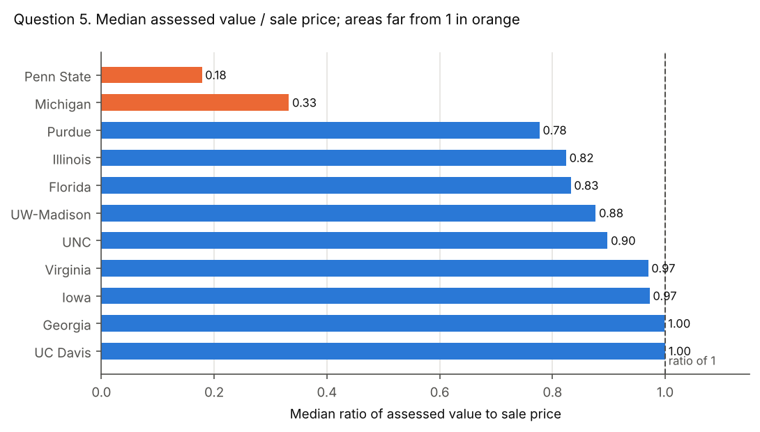

Model answer
Two areas are far from 1: Penn State (0.18) and Michigan (0.33). The other 9 areas run from 0.78 to 1.00, with UC Davis at 1.00.
Penn State (Pennsylvania). Pennsylvania counties assess against a "base year" and reassess at irregular intervals (Babst Calland, 2023). The state measures how far assessments have drifted with a common level ratio for each county. For Centre County, the July 2026 factor is 6.10, and the factor is the reciprocal of the ratio, so assessments sit at about one sixth of market value (Pennsylvania Department of Revenue). That matches the data's 0.18.
Michigan. Michigan's constitution caps assessed value at 50 percent of true cash value. Taxable value can rise each year only by inflation or 5 percent, whichever is less, until the home sells (Michigan State Tax Commission). Assessments at half of value would give about 0.5. The data's 0.33 is lower still, which fits a field holding the capped taxable value, or assessments that lag rising prices. The dataset does not say which.
For contrast, UC Davis (California). California reassesses a home at its purchase price when it changes hands, and the value can then rise by at most 2 percent a year (California State Board of Equalization). A recent sale resets the assessment to about the sale price, so the median ratio is 1.00.
Do not read a state's statutory assessment level into this column. Illinois, for example, sits at 0.82 here. The values are as the collection source reported them.
Sources, checked October 11, 2026:
- Pennsylvania tax assessment appeals and common level ratios (Babst Calland, October 6, 2023)
- 2025 Common Level Ratio Real Estate Valuation Factors (Pennsylvania Department of Revenue, July 2026)
- Guide to Basic Assessing (Michigan State Tax Commission, May 2018)
- Assessors' Handbook Section 401, Change in Ownership (California State Board of Equalization, reprinted January 2015)

Common wrong answers
Mean, ratio of medians, inverted ratio, or invalid sales kept. The ratio is computed per sale, then the median is taken. Including sales under $1,000 divides by tiny prices and wrecks a mean.
Campus area | correct: median of per-sale ratios | mean of per-sale ratios | median assessed value / median sale price | ratio inverted (sale price / assessed value) | mean including sales under $1,000
Purdue University | 0.78 | 0.89 | 0.76 | 1.29 | 0.89
The Pennsylvania State University | 0.18 | 0.25 | 0.19 | 5.61 | 0.40
The University of Iowa | 0.97 | 0.97 | 0.94 | 1.03 | 0.97
The University of North Carolina at Chapel Hill | 0.90 | 1.25 | 0.82 | 1.11 | 1.25
University of California, Davis | 1.00 | 0.88 | 0.90 | 1.00 | 0.88
University of Florida | 0.83 | 0.91 | 0.82 | 1.20 | 0.91
University of Georgia | 1.00 | 1.34 | 0.98 | 1.00 | 2.36
University of Illinois Urbana-Champaign | 0.82 | 0.84 | 0.79 | 1.21 | 0.84
University of Michigan | 0.33 | 0.80 | 0.35 | 3.01 | 135.79
University of Virginia | 0.97 | 0.99 | 0.94 | 1.03 | 0.99
University of Wisconsin-Madison | 0.88 | 0.86 | 0.87 | 1.14 | 0.86

Tolerance
- Each median ratio: within 0.01.
- Names Penn State and Michigan as far from 1, with a stated threshold. Naming other areas is correct only if they meet the student's own threshold; the next closest is Purdue at 0.78. Naming UC Davis as far from 1 is wrong under any threshold.
- The explanation must rest on how each state assesses property, and the case asks for a source. A claim that homes there sell far above their value earns no credit.

Question 6. Buildings
Group sales by street address, city, state and ZIP code. In each campus area, how many addresses have more than one sale, and how many sales do they cover? How does the median miles_to_campus of those sales compare with that of all other sales, across all areas and within each area?

Figures
Addresses with more than one sale
Campus area | Addresses | Sales at those addresses | Median miles, those sales | Median miles, all other sales
The Pennsylvania State University | 13 | 60 | 0.5 | 2.2
The University of North Carolina at Chapel Hill | 1 | 2 | fewer than 20 sales | 3.75
University of Florida | 1 | 2 | fewer than 20 sales | 4.4
University of Virginia | 1 | 2 | fewer than 20 sales | 3.4
Purdue University | 0 | 0 | no sales | 3.8
The University of Iowa | 0 | 0 | no sales | 2.2
University of California, Davis | 0 | 0 | no sales | 2
University of Georgia | 0 | 0 | no sales | 3.7
University of Illinois Urbana-Champaign | 0 | 0 | no sales | 2.8
University of Michigan | 0 | 0 | no sales | 2.7
University of Wisconsin-Madison | 0 | 0 | no sales | 4.8
All campus areas | 16 | 66 | 0.5 | 3.4

Chart
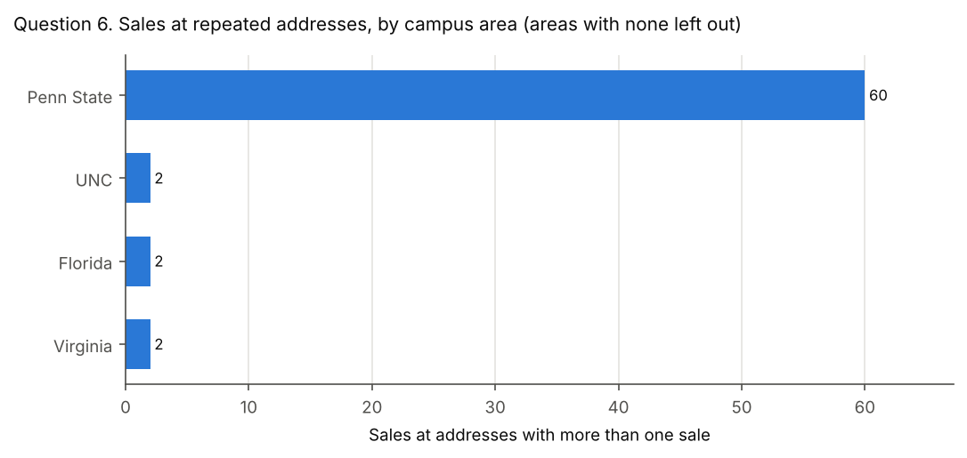

Model answer
In all, 16 addresses have more than one sale, covering 66 sales. Almost all are around Penn State (13 addresses, 60 sales). UNC, Florida and Virginia have one such address each, and Purdue, Iowa, UC Davis, Georgia, Illinois, Michigan and UW-Madison have none.
Across all areas, those sales sit a median 0.5 miles from campus, against 3.4 for all other sales. Within an area, only Penn State has 20 or more such sales. There they sit much closer to campus than other sales, 0.5 miles against 2.2, which fits condo and apartment buildings near campus. The other areas have fewer than 20 such sales.
Instructor note: what the repeated addresses are. The 60 sales around Penn State are condo and apartment units in 13 buildings, each unit with its own parcel number. The other 6 sales are pairs: two different sales, at different prices and about a year or more apart, at each of 3 homes built in 2023 or 2024. The description sheet explains both. A student who says the repeated addresses are mostly condo buildings close to campus is right.

Common wrong answers
Grouped by street name only, or duplicates removed first. Grouping by street name alone merges same-named streets in different towns. Removing duplicate addresses first leaves nothing to count. Counting only the extra sales (sales minus addresses) understates the total.
Method | Addresses | Sales | Median miles of those sales
correct | 16 | 66 | 0.5
grouped by street name only | 52 | 138 | 2.1
after removing duplicate addresses | 0 | 0 | none
extra sales only | 16 | 50 | 0.5

Tolerance
- Counts: exact. 16 addresses and 66 sales in total, and each area's counts as in the table. Counts are always shown, even for small areas.
- Median miles: within 0.05 miles. In areas with fewer than 20 such sales, the median must show "fewer than 20 sales".
- The question asks for the comparison across all areas and within each area, so full credit needs both: the overall comparison, Penn State's comparison, and "fewer than 20 sales" for each other area that has such sales.

